

LastOSLinux

User Manual

2024 v0.2

## 

Mission Statement 3

Installing LastOSLinux 4

LastOSLinux Settings 5

LastOSLinux Store 6

LLFile Editor 8

Context Menus 9

Global Shortcut Keys 10

## 

# Mission Statement

LastOSLinux was developed during the 2nd half of 2024 with the goal of replacing Windows installations on hardware that wasn’t able to properly upgrade to Windows 11, although it also works well on modern hardware, its focus is being lighter on resources than some other distributions. it isn’t a light OS as it includes a lot of applications and games that many users would want to use. The main concept was to create an Application Management system that is able to work off locally stored and online repositories. Many of Linux’s tools will self update if installed using the default repositories, LastOSLinux Store only automates this task, the store is more than just Apps and Games, it also offers tweaks, themes and offers fixes you can optionally apply to your installations. The reason so many applications are included by default is to allow someone who might never have installed a PC to use it without knowing where to find them, what things are called or learning how to install from a store that shows everything (including libraries and runtimes) or how to install them from a terminal. You are still able to access all the advanced tools and methods, to adopt as your skills and needs develop. But think of a person who only wants to get on the internet, look at or edit photos, print a few things, watch videos, listen to music or play some basic games to fill in time.

Many of the Computers/Laptops that I salvage and refurbish are lower spec and would otherwise have been landfill, this shouldn’t be something anyone does with their old hardware, many places are very willing to accept your old things and share/sell them to someone who can’t go buy the latest Laptop, or even if it’s a broken laptop, others aren’t able to pay to upgrade their memory or fix a broken HDD when it fails, so a lot of what many consider rubbish is still able to provide benefits to others. So donate your old hardware to your local online center or drop them off at an op shop and they will make sure it gets to people who can use them.

I have spent over 25 years modding Windows operating systems and automating common tasks, as well as I do not like the way Windows is following Apple’s footsteps in trying to get people to subscribe to have convenience at the cost of freedom and choice. The best operating system for home users and beginners is one that isn’t an ultra light or locked fortress where every decision needs to be asked, every action requiring a password, it is simply a tool that gets the results without them needing to know how things work, or why they work. Many home users are the only people who will use their computer and having a login password and a lock screen is enough for them, especially as Google, Microsoft etc are all moving away from passwords and instead using two-factor authentication and alternatives. By relaxing the security enough that a basic user is able to use their computer without getting frustrated by it, they are more likely to keep using it in the future.  
  
Using the skills I gained and the knowledge of home users needs, I took the first steps into making a free and open alternative, as I’d not use Linux since 2012 I was happy to see how much more capable it had become, but none of them felt like using Windows 10, they just felt different and a little off. WINE was meant to fix this feeling by giving users the same applications running on Linux, but many of the things needed to get it working needed time and effort to sort out, instead of making any of that stuff optional, for the sake of about 200mb of HDD space, I have included them all by default, fonts, libraries, runtimes, all of it. The same with older Linux games, many of them were never updated to work with the newer Linux, so for the sake of another 300mb HDD space I’ve included all them too. Now you're able to just run things, like you do on windows, and it’s all still a lot smaller than windows WinSxS folder that does a similar job. The mindset that linux should only include the things it needs to do the jobs one person need is one of the barriers that stop new users from becoming frustrated when they follow the instructions they find online that were written 9 years ago and they don’t work, by including all the things I do, they do work and while I was testing they work I made them available from LastOSLinux store.

# Installing LastOSLinux

The first step to installing LastOSLinux is making a bootable USB (or burn a DVD if you prefer), I have included the tools to make a USB in the OS, but you will not be able to use them until you have 1 PC installed with LastOSLinux, instead you will manually have to download Ventoy,

<https://www.ventoy.net/en/doc_linux_gui.html>

Once you have installed a USB with Ventoy you are able to copy the LastOSLinux_amd64_2024-xx-xx_xxxx.iso file to the USB drive, that is all you need to do.

If you only have a Windows PC you can download and use Rufus to make a bootable USB:

<https://rufus.ie/downloads/>

Download the portable version, extract it and run Rufus.exe, pick the ISO, pick the USB and when asked to download syslinux, allow this to happen. It will take longer if your USB drive is slower, from about 7 minutes for a USB 3 HDD/SSD and up to 50 minutes on a USB 2 speed one.

Once you boot your USB you will need to decide if you want to erase everything on your PC or manually partition it to work with existing Data or even keeping your Windows installation. The main thing you need to know is you need to make a 600mb boot/efi drive (for best futureproofing) and if it’s not EFI then you will need to make a 100mb FAT32 partition and set that to boot and grub.

I always recommend you make the main / (System) disk above 120 to 180GB and the rest of the space set aside for your data /home partition, although the system would be fine with 60GB, the more apps and games you install the more space you need, 120GB is where I found most people could get by. The data drive should be over 80GB but more is better.

If you have 2 Disks in the computer you are better to make 1 of them dedicated to the system disk and then set the 2nd HDD to be the data disk for your /home folders

The reason I recommend having data on a 2nd disk is to make sure if you need to reinstall or it fails, you’ll have your data safe on the other disk. But even a 2nd partition lets you reinstall without having to do duplicate backups or restore after the install.

Many people who are just starting out using Linux are recommended that you remove your Windows HDD/SSD/M.2 and replace it with another spare/new one for Linux, this is a very cautious approach and if you chose to do so then make sure to backup the data that’s on it first so that you can easily access it off a USB or online backup.

Once the Operating system is installed, on the first boot it will set up WINE and configure things to work as easily as possible, do not interrupt it while it does the automated tasks, it will leave a notification bell with one notification saying Install Completed when it’s ready to use, this is only to stop you skipping over the jobs and tools it provides you.

# LastOSLinux Settings

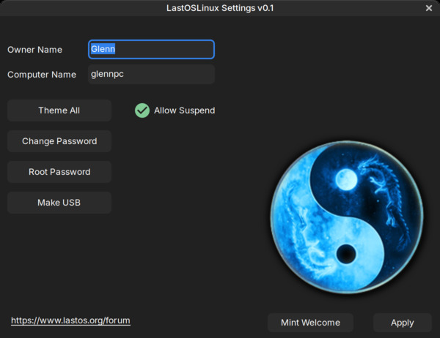

The settings app is a new addition to LastOSLinux, it is just a way to access the tools and settings most users need after a fresh installation, it also includes a way to run Linux Mint’s welcome screen if you want to follow through their first boot information. The Settings offer themes that will change ALL themes to Dark or all to light, it will include more options in the future, it just needs to be in place so the LastOS Updates will work as intended.

**Owner Name:** This is the full name of the user, shown on the login screen and used in some apps.

**Computer Name:** This is how you can identify your OS on the network, browse shares etc.

**Theme All:** Select a premade theme and layout that suits your style.

**Change Password:** Change your set password or if you install for someone else set the password to “x” so they can change it after they receive their Computer.

**Root Password:** If you set the root password you are able to login as root from the terminal, this is not usually needed.

**Make USB:** This opens up a document, runs Ventoy and walks you through building a Bootable LastOSLinux USB Installer.

**Allow Suspend:** This is on by default, if you install weird hardware, sometimes a PC will suspend but not wake up fully, the best way to stop this is to remove the option from the shutdown screen. (iMac 2009)

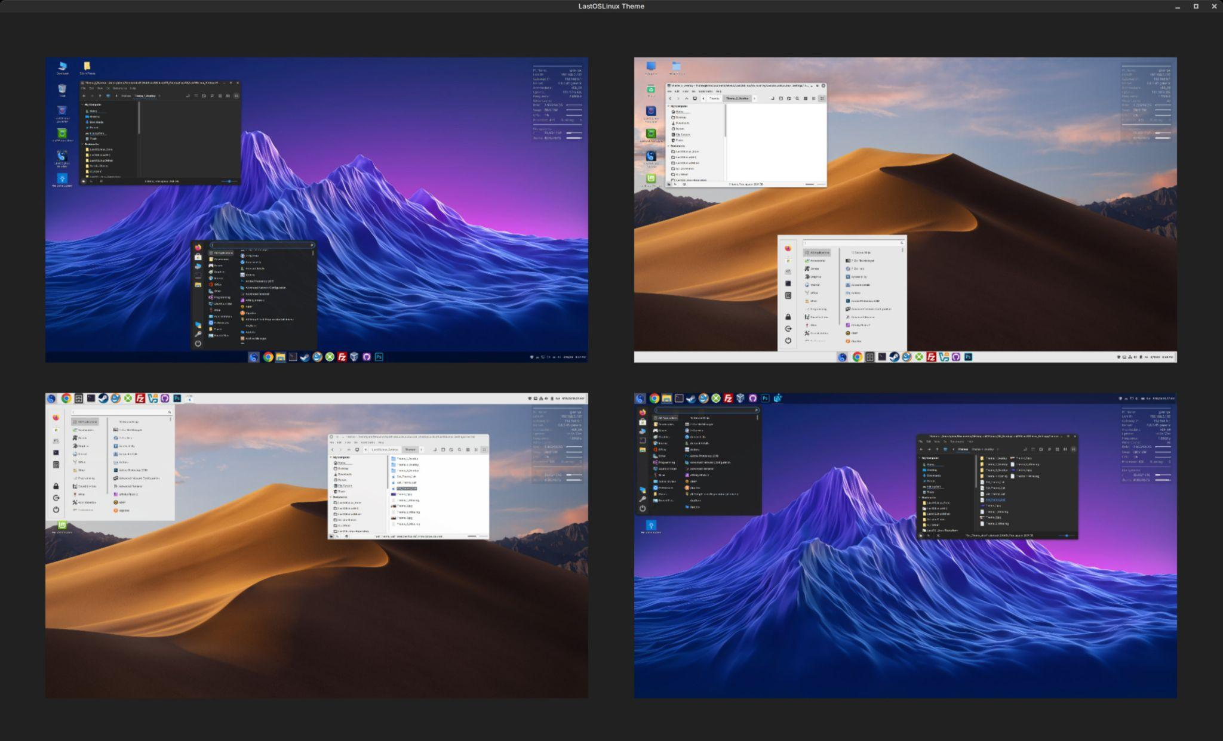

Theme All

# LastOSLinux Store

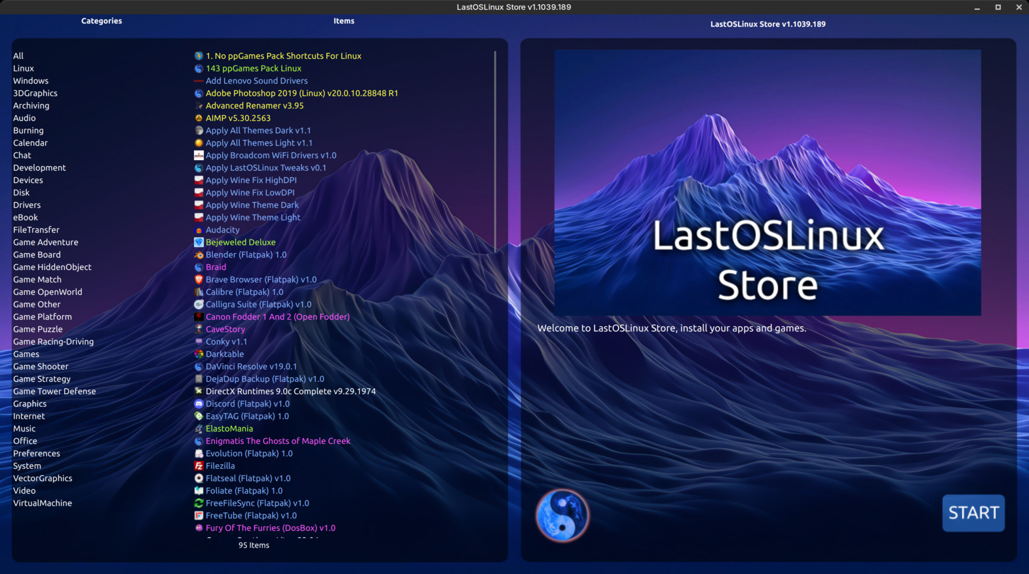

The main part of all LastOS releases is having the ability to have an AIO location to access all the optional tools, apps, games and tweaks we recommend to improve your experience. The store is a catalog of Online and locally available files, it uses LLApp for the apps and LLGames for the games they can be in a folder which will not have to be extracted before it’s installed, making it faster if your using it on an older PC with a Magnetic HDD or a USB 2 source. They are only packaged into archives to make downloading them much quicker and easier, as they are kept in a single uncompressed .tar file (archived). The store also offers the ability to install ppApps and ppGames which are what LastOS uses in Windows for it’s Permanent Portable items (they are portable), not installed, but create shortcuts and keep settings in it’s own folder where possible, instead of integrating into the operating system. Windows also offers ssApps which do install like a system integrated app. These require SetupS (the tool used in LastXP, LastOS 7, 10 and 11), which is one of the tools installed on first login.

The Store can also be run as a Launcher to preview all of the installed LLGames and ppGames you have on the system. Able to start them running without needing to hunt them down. It offers a way to set the screen resolution (by holding shift or right clicking games) as well as the ability to press Ctrl + Break or Ctrl+Shift+F4 to quit ALL wine running apps/games, reset the screen resolution back to your default desktop one and makes your system recoverable from a game freezing/crashing.

The store can be automated to install a saved preset using the command line arguments and it can include Manual scanned locations. It offers a settings screen in case you want to disable local or remote/online repositories and other options. By default almost all LLGames will install to ~/LLGames/ and LLApps will generally install to other folders but ~/LLApps/ is available to use.

If you want to use the store in VirtualBox you must have 3D Acceleration enabled in the Display section or pick Wayland from the login screen. Because it uses QT5 it will crash the display driver and log you out otherwise. I recommend VirtualBox v7.1.2 or newer as they added stable graphics support for Ubuntu v24.04 which Mint v22 and LastOSLinux is based on.

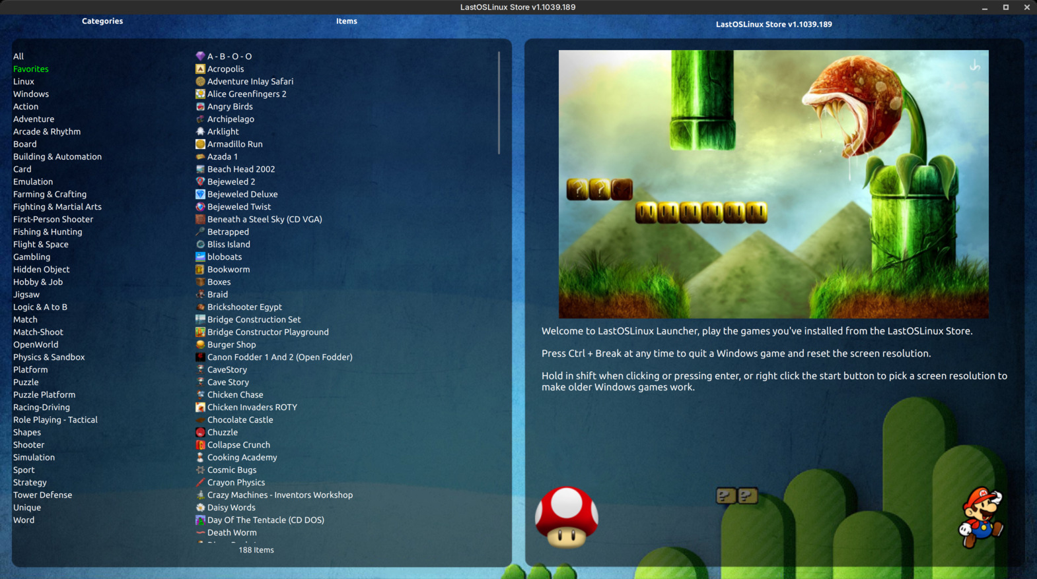

Launcher

# Store Shortcuts

Space: Select Item for Install

F3: Add Manual Location

F5: ReScan for Items

F7: Toggle Store or Launcher Mode

F8: Settings Screen

F9: Debugger

F11: Full Screen

Ctrl + A: Select All

Ctrl + N: Select None

Ctrl + I: Select Invert

Ctrl + O: Load Preset

Ctrl + S: Save Preset

Alt + S: Save to List

Alt + E: Edit Item

Escape: Quit

Alt + F4: Quit

Launcher Only:

Enter: Run Item

Shift + Enter: Run Item Set Screen Resolution

Ctrl + F: Add to Favorites

Ctrl + R: Remove from Favorites

Alt + D: Make Desktop Shortcut

Alt + A: Autobuild To Desktop

Holding Shift when you press Start or Double Click an item to run it will first open the Screen Resolution Options.

Holding Ctrl and using the Mouse Wheel over Items or Description will zoom them in or out.

Holding Ctrl and pressing Start will build a Repository to the Desktop of all found Local Items.

Holding Ctrl and clicking the Fader Picture will open the debugger window.

Use the global hotkeys of Ctrl + Shift + F4 or Ctrl + Break to quit all running WINE games and restore the desktop resolution.

# 

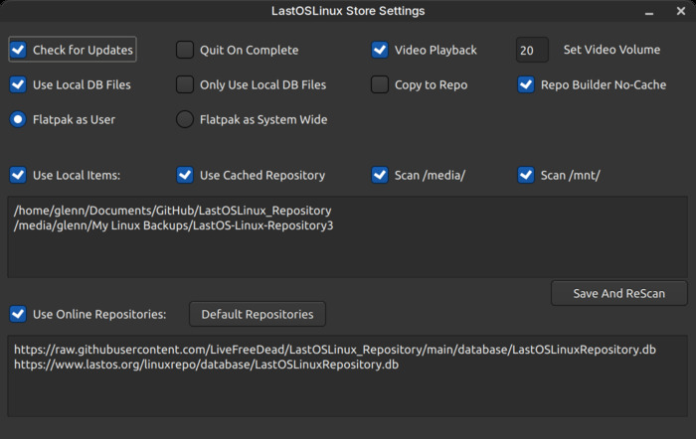

Store Settings

**Check for Updates:** As you run Store it will check online for a new version and install that for you.

**Quit On Complete:** If you use Store to install multiple items it will show the Mini Installer, once that completes installing it will quit the Store if this is enabled.

**Video Playback:** If you include a LLApp/LLGame.mp4 file in with your games and apps it will show the screenshot for 4 seconds then start playing the video, this is mostly used for the Games Launcher to see the gameplay before starting the game.

**Set Video Volume:** The video played above will have sound and you can set the volume from 0 - 100.

**Use Local DB Files:** If this is enabled your item locations will be scanned once and keep a database of what they include, this is on by default, if you add or remove items you will have to rescan your items to update the Database, or it will show items that don’t exist, or not show your new items (can press F5 to do this).

**Only Use Local DB Files:** This will stop any scanning for items and only use the Databases.

**Copy To Repo:** When you are building an online repository often you’ll want to also upload the packages, this will copy the packages to the Desktop Repository folder (can be large if including games etc).

**Repo Builder No-Cache:** Below you can turn on Use Cached Repositories, this will scan the ~/zLastOSRepository folder for compressed items and add them to the list, if you are always building online repositories, this will add extra items you may not want, this will let you leave the below option set (so can share the update store source code without me having to change it back every time.

**Flatpak as User:** This is the default option, it will install Flatpaks for the current user only, this is good because the apps will still be available if you reinstall your OS.

**Flatpak as System Wide:** This makes Flatpaks available to all Users, but if you wipe your System disk it will erase all the settings and apps/games with it.

**Use Local Items:** If you wish to have it be Online only you can disable this, it will skip scanning local items.

**Use Cached Repository:** As you download things, they are kept in ~/zLastOSRepository, you are able to re-install them or even build a repository with them if you don’t enable No-Cache setting.

**Scan /media/ /mnt/:** You can set it to only scan manual locations if you disable both these, else it will scan all internal disks /mnt/ and any USB/DVD disks if you pick /media/

**Manual locations** are shown in the first list and can be edited, if they don’t exist, they aren’t scanned, so I put a 3 at the end to disable them to build an online Repository.

**Use Online Repositories:** This will check the following URLs for databases to use as an online store.

**Default Repositories:** If you accidentally mess up the repositories you can revert to the ones I originally created for LastOSLinux Store.

**Save And ReScan:** If you change any options you’ll generally want to save your settings then rescan for the changed options. Settings are saved as you change them, but are usually not applied until you restart or Rescan.

# LLFile Editor

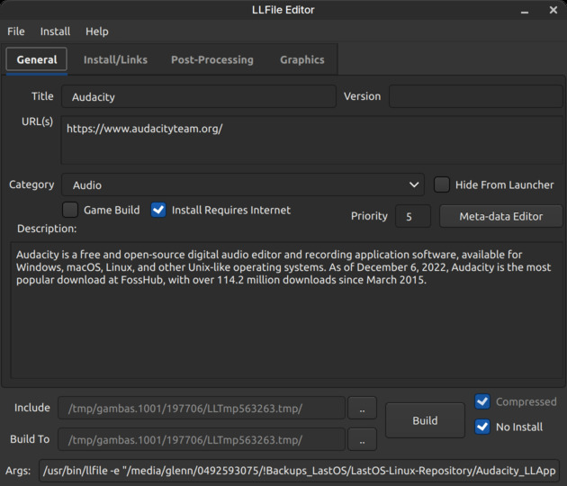

To make use of the store you need new apps and games, the way to make them is by using LLFile Editor, this tool’s job is to make sure things stay standardized and can be used for all the features available in the Store. This tool is not able to edit ppApp/ppGames or ssApps, these can be edited with ssEditor, which is a Windows version of the tool, I left this tool included to keep the existing library of apps hosted at LastOS;

<https://repo.lastos.org/list_v3a.php?dir=repo&sort=date&order=desc>

Not all the apps will work on LastOSLinux, they are mainly for actual Windows OS’s to use.

The other task LLFile does is the actual installing of the Store apps and games, this tool is directly integrated into Store, but the standalone version can be used to install apps and games directly from nemo explorer, the context menu or even from the terminal.

Command Arguments:

llapp or llfile -i: Install (Default if no - command given), -e: Open for Editing, -c: Compress (Builds first if needed), -b: Build only.  
  
Example: llapp -i ./App.I.Downloaded.LLApp.tar

# Context Menus

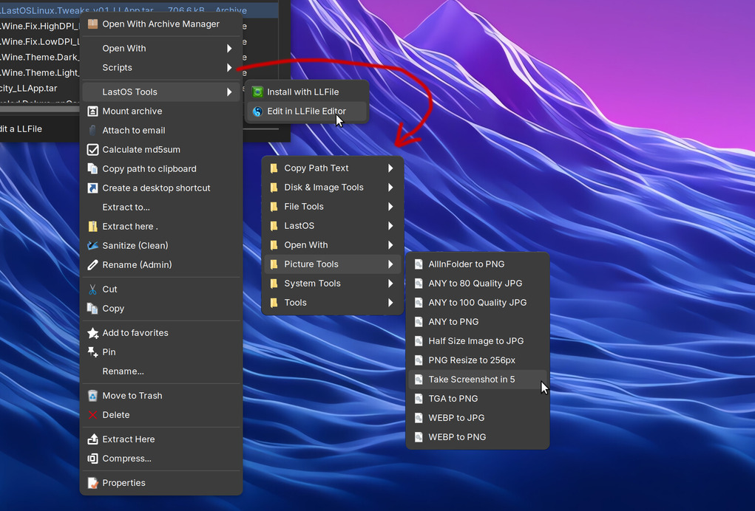

One of the most powerful timesaving tools is the context menu (right mouse button), instead of navigating to the tools you need and then opening the files you want to work with, you simply right click the file/folder and use the context menu to process them directly, or open them.

**Scripts:**

Copy Path Text/All - Filenames.Ext

Copy Path Text/All - Subs - Filenames.Ext

Copy Path Text/All - Subs - Paths Only

Copy Path Text/Selected - Filenames

Copy Path Text/Selected - Filenames.Ext

Copy Path Text/Selected - Path - Filenames.Ext

Disk & Image Tools/ISO from A Folder Contents

Disk & Image Tools/Mount VHD (Sudo)

Disk & Image Tools/Mount VHD Alt (Sudo)

File Tools/Set Executable

File Tools/Set Not Executable

File Tools/TAR from A Folder Contents

File Tools/TAR.GZ from A Folder Contents

File Tools/ZIP Folder with SymLinks

File Tools/ZIP from A Folder Contents

LastOS/LLFile Build

LastOS/LLFile Compress

LastOS/LLFile Editor

LastOS/LLFile Install

LastOS/Sanitize (Clean)

LastOS/SetupS (Install)

LastOS/SetupS Editor

LastOS/ssEditor(Autobuild Archive)

LastOS/ssEditor(Autobuild Folder)

Open With/Gambas3

Open With/LLFile Editor

Open With/Text Editor

Open With/Wine

Picture Tools/ANY to 100 Quality JPG

Picture Tools/ANY to 80 Quality JPG

Picture Tools/ANY to PNG

Picture Tools/AllInFolder to PNG

Picture Tools/Half Size Image to JPG

Picture Tools/PNG Resize to 256px

Picture Tools/TGA to PNG

Picture Tools/Take Screenshot in 5

Picture Tools/WEBP to JPG

Picture Tools/WEBP to PNG

System Tools/Display USB Cache

System Tools/Nemo Restore Windows

System Tools/Nemo Save Windows

System Tools/Panel to Centre

System Tools/Panel to Left

System Tools/Power Settings

System Tools/Preferred Applications

System Tools/Restart Cinnamon

System Tools/Restart Nemo

System Tools/System Settings

System Tools/gParted

Tools/GSettings to List

Tools/Get Modded Files Start

Tools/Get Modded Files Stop

Tools/dconf watch (Regshot)

**Scripts-Tools-GSettings to list:** Saves a text document to the desktop with all known registry type stored values.

**Scripts-Tools-dconf watch (Regshot):** Monitors all Registry type changes to settings.

**Scripts-Tools-Get Modded Files:** This will list all the files changed between the Start and Stop being used and save them to a text document on the desktop.

**LastOS Tools**: This has all the LLFile Editor and Installer options in it.

**Extract Here .:** This extracts the context of an archive to the current path with no subfolder made first.

**Sanitize:** This uses the Windows version of my Filename Cleaner, I will make a Linux version soon.

**Rename Admin:** Use this to rename any file system wide or rename the actual .desktop file, instead of it only changing the label inside it.

**XED (Sudo):** Opens any document as root and the ability to save it once edited.

# Global Shortcut Keys

(Open Keyboard App to see more)

Ctrl + Alt + Backspace: Log Out Instantly

Ctrl + Alt + Escape: Restart Cinnamon

Ctrl + Alt + L: Lock Screen

Ctrl + Alt + End: Shutdown

Ctrl + Shift + Escape: Gnome System Monitor

Ctrl + Alt + Delete: Gnome System Monitor

Ctrl + Shift + F4: Kill all WINE Apps/Games and restore to Desktop Resolution

Ctrl + Break: Kill all WINE Apps/Games and restore to Desktop Resolution

Alt + Break: Restore to Desktop Resolution

Alt + =: Screen Brightness Up

Alt + -: Screen Brightness Down

Ctrl + Alt + T: Open Terminal Window

Super + E: Open home folder

Alt + F7: Move Window

Ctrl + Alt + Shift + R: Toggle recording desktop

Ctrl + Alt + F1 - F6: Open Terminal TTY

Ctrl + Alt + F7: Switch back to GUI